**Project Title**

STS Courier Services (Courier Service Management project application)

**Description**

The primary goal of our Courier Service Management project is to streamline and enhance the process of sending and receiving packages, ensuring efficient and reliable courier services for businesses and individuals. Our platform enables users to access a range of courier services, track their shipments, and manage their deliveries seamlessly.

Key Features:

1. Package Booking: Users can easily book courier services online, specifying package details, pickup, and delivery locations.
2. Shipment Tracking: Real-time tracking of shipments allows users to monitor the status and location of their packages at any time.
3. Service Options: We offer a variety of service options, including express delivery, standard shipping, and special handling for fragile or sensitive items.
4. Delivery Confirmation: Receive notifications and confirm deliveries, providing peace of mind to both senders and recipients.
5. Payment Options: Multiple payment methods are available for secure and hassle-free transactions.
6. Courier Company Management: Admins can manage courier companies, their services, and user accounts with ease.

Figure 1Admin Functionalities

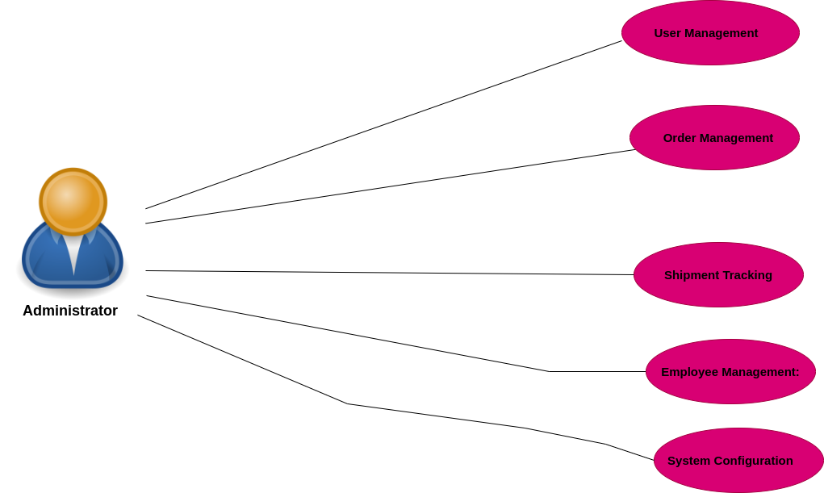

Figure 2 Delivery Personnel Functionalities

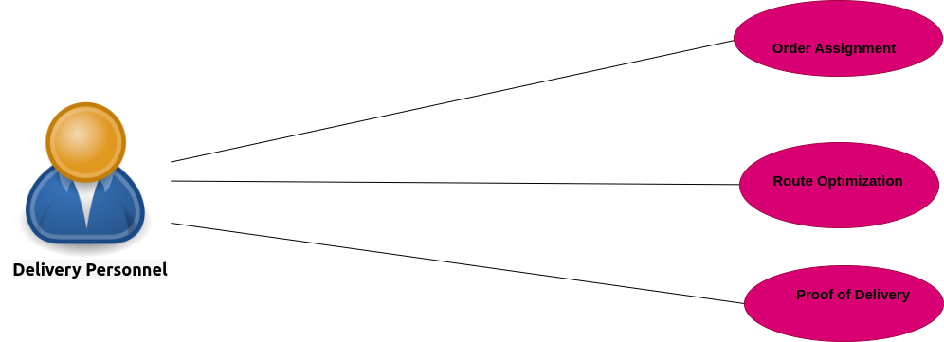

Figure 3 Customer Functionality

